**Karnataka Law Society’s**

**Gogte Institute of Technology, Belgaum.**



*Report on,*

**Recurrence Relation & Generating Function**

### Submitted to: Prof. Jeetendra R. Gurjar

By,

|  |  |  |  |
| --- | --- | --- | --- |
| **Name** | **Roll No.** | **USN** | **Signature** |
| Shradha.M.Patil | I 2 | *2GI20CS144* |  |
| Gouri.N.Huddar | I 45 | *2GI20EE009* |  |
| Omprakash Jat | I 47 | *2GI20IS020* |  |
| Smruti .S.Bhandiwad | I 49 | *2GI20IS041* |  |

**Contents:**

1. Introduction to Discrete Mathematics
2. Fibonacci Problem
3. Recurrence Relations
4. Generating Functions
5. Applications of Generating functions

**What is Discrete Mathematics?**

* Discrete mathematics is the study of mathematical structures that are countable or otherwise distinct and separable.
* Examples of structures that are discrete are combinations, graphs, and logical statements. Discrete structures can be finite or infinite.
* Discrete mathematics is in contrast to continuous mathematics, which deals with structures which can range in value over the real numbers , or have some non-separable quality.

Everyday Applications of Discrete Mathematics

Computers

The software and files are both stored as huge strings of 1s and 0s. Binary math is discrete mathematics.

Google Maps

It uses discrete mathematics to determine fastest driving routes and times

Cryptography

Encryption and decryption are part of cryptography, which is part of discrete mathematics. For example, secure internet shopping uses public-key cryptography

Digital image processing

It uses discrete mathematics to merge images or apply filters

Example:

Tower of Hanoi

The objective of the puzzle is to move entire stack to another rod obeying the following rules :

* Only one disk may move at a time.
* Each move consists of taking upper disk from one of the rods & sliding it onto another rod, on top of the other disks that may already be present on that rod.
* No disk may be placed on top of a smaller disk.



* Step 1 − Move n-1 disks from source to aux
* Step 2 − Move nth disk from source to dest
* Step 3 − Move n-1 disks from aux to dest

Total Number of moves needed to solve for | | given ‘N’ disks : 2n – 1 |

**Fibonacci Problem:**

* A farmer raises rabbits. Each rabbit gives birth when 2 months old and then each month there after.
* Question: How many rabbits will the farmer have after n months? Try it on small numbers.
* Fn ... the number of rabbits after n month. Each rabbit alive the n-1th month remains nth month. Each rabbit alive the n − 2th month adds one more rabbit to nth month.

F1 = 1   
F2 = 1   
Fn+1 = Fn + Fn−1 if n ≥ 2

* This formula is an example of a recurrence formula (as opposite to an explicit formula).
* Recurrence formulas are often easy to obtain (and easy to code). Often we extend the sequence by starting,  
  F0 = 0,  
  F1 = 0,  
  F2 = 1 Fn+1 = Fn + Fn−1 if n ≥ 1
* Sequence of Fibonacci numbers 0, 1, 1, 2, 3, 5, 8, 13, 21, 34, 55, 89, 144, 233, . .
* For that reason, Fibonacci numbers have been studied in detail. Some basic identities: F0 + F1 + F2 + · · · + Fn = Fn+2 − 1 F1 + F3 + F5 + · · · + F2n−1 = F2n F0 − F1 + F2 − F3 + · · · − F2n−1 + F2n = F2n−1 − 1 Fn−1Fn+1 − F 2 n = (−1)n

**Recurrence relations:**

A recurrence relation is an equation that recursively defines a sequence where the next term is a function of the previous terms (Expressing Fn as some combination of Fi with i<n).

Example − Fibonacci series − Fn=Fn−1+Fn−2Fn, Tower of Hanoi − Fn=2Fn−1

Types of recurrence relations

* First order Recurrence relation: -

 A recurrence relation of the form: an = can-1 + f(n) for n>=1  
where c is a constant and f(n) is a known function is called linear recurrence relation of first order with constant coefficient. If f(n) = 0, the relation is homogeneous otherwise non-homogeneous.

Example :- xn = 2xn-1 – 1, an = nan-1 + 1, etc.

Backtracking Method

The first method is called backtracking, and consists of taking a linear recurrence defining an, and replace the terms an-1,an-2,... with the relation that defines an, but where n is replaced by n - 1, n - 2, etc.

* Example:- an=an-1 +3 , a1=2

Then an-1 = an-2 +3

an-2 = an-3 +3

an-3 = an-4 +3 and so on.

Therefore,

an=an-1 +3

=(an-2 +3 )+3 =an-2 +2*3

=(an-3 +3)+6 =an-3 +3*3 . . .

=a1+(n-1)*3.

So,

an =2+(n-1)*3

Second order liner homogenous recurrence relation:

Definition:

A recurrence relation of the form  
 Ban + Can-1 + Dan-2 = 0 ——> (1)

is called a second order linear homogeneous recurrence relation with constant coefficients.  
Solution to this is in form an = rn where r!=0  
Putting this in (1)  
 Brn + Crn-1 + Drn-2 = 0  
 r2 + r + 1 = 0 —–> (2)

Thus, an = rn is solution of (1) if r satisfies quadratic equation (2). This equation is called characteristic equation for relation (1).

Various Cases

1. Real and Distinct roots
2. Complex roots
3. Repeated Real Roots

Procedure to solve:

* Given equation
* Change the given equation $a_{n}$ into $r^{n}$
* Divide by the lowest $value of r$
* Quadric equation
* Find the two roots r1 , r2
* Solve

Case 1: When Roots are Real & Distinct

If the two roots k1, k2 of equation are real and distinct then, we take  
 an = A(k1)n + B(k2)n

as general solution of (1) where A and B are arbitrary real constants.

Example:

an =5 $a_{n-1}-6a_{n-2}$ where $a_{0}=1 a_{1}=1$

= $r^{n}-{5r}^{n-1}+{6r}^{n-2}=0$

= Divide by lowest power

= $r^{2}-5r+6=0$

= r1 =3 r2 =2

= an = A(r1)n + B(r2)n

= n=0, n=1,

= A+B=1 3A+2B=1

= Solving we get A=-1 B=-2

= an = -1(3)n + 2(2)n

Case 2: When Roots are Real & Equal

If the two roots k1, k2 of equation are real and equal, with k as common value then, we take  
 an = (A + Bn)kn

as general solution of (1) where A and B are arbitrary real constants.

Case 3: When Roots are Complex

If the two roots k1 and k2 of equation are complex then, k1 and k2 are complex conjugate of each other i.e k1 = p + iq and k2 = p – iq and we take

an = rn(Acosnθ + Bsinnθ)

as general solution of (1) where A and B are arbitrary complex constants, r = |k1| = |k2| = √p2 + q2 and θ = tan-1(q/p).

**Generating Function:**

Working with a continuous function is sometimes much easier than working with a sequence. For example, in the analysis of functions, calculus is very useful. However, the discrete nature of sequences prevents us from using calculus on sequences. A generating function is a continuous function associated with a given sequence. For this reason, generating functions are very useful in analyzing discrete problems involving sequences of numbers or sequences of functions.

Definition

Let $a_{0},$ $a_{1}$, $a_{2}$, $a_{3}$….. ∞ be a sequence of real numbers denoted as {$a_{n}$}

Then a series in power of x, such that

G(x)= $a_{0}+a_{1}x+a_{2}x^{2}+a_{3}x^{3}\text{…..}\text{ ∞}$

G(x)= $\sum_{n=0}^{\text{∞}}{a_{n}}$ $x^{n}$, is called a generating function of series {$a_{n}$}

Example:

1. If we have a sequence with $a_{n}$ =n+1 Then the generating function for this sequence is,

G(x)= $\sum_{n=0}^{\text{∞}}{(n+1)}$ $x^{n}$

Find the generating function for the series 1, -1 , 1 , -1 , 1,…. $\text{∞}$

Solution:

Let $a_{n}$ =1, -1 , 1 , -1 ,….. $\text{∞}$

WKT,

G(x)= $a_{0}+a_{1}x+a_{2}x^{2}+a_{3}x^{3}\text{…..}\text{ ∞}$

$a_{0}$ =1 , $a_{1}$ =-1 , $a_{2}$ =1,…..

G(x)= $1-x+x^{2}-x^{3}\text{…..}\text{ ∞}$

G(x)= $\frac{1}{1+x} \{Closed form of the series\}$

Similarly, The generating function for the series 1, 1, 1, 1.. is,

G(x)=

2) Find the Generating function for the sequence 3, 7, 11, 15….

Solution:

Let $a_{n}$ =3, 7, 11, 15….. $\text{∞}$

We know that,

G(x)= $a_{0}+a_{1}x+a_{2}x^{2}+a_{3}x^{3}\text{…..}\text{ ∞}$

$a_{0}$ =3, $a_{1}$ =7 , $a_{2}$ =15,…..

G(x)= $3+7x+11x^{2}+15x^{3}\text{…..}$

xG(x)= $3x+7x^{2}+11x^{3}\text{…..}$ (Multiply by x and subtract)

(1-x)G(x)= $3+4x+4x^{2}+4x^{3}\text{….. }$

(1-x)G(x)= $3+\frac{4x}{1-x}$

G(x)= $\frac{3}{1-x}+\frac{4x}{{(1-x)}^{2}}$

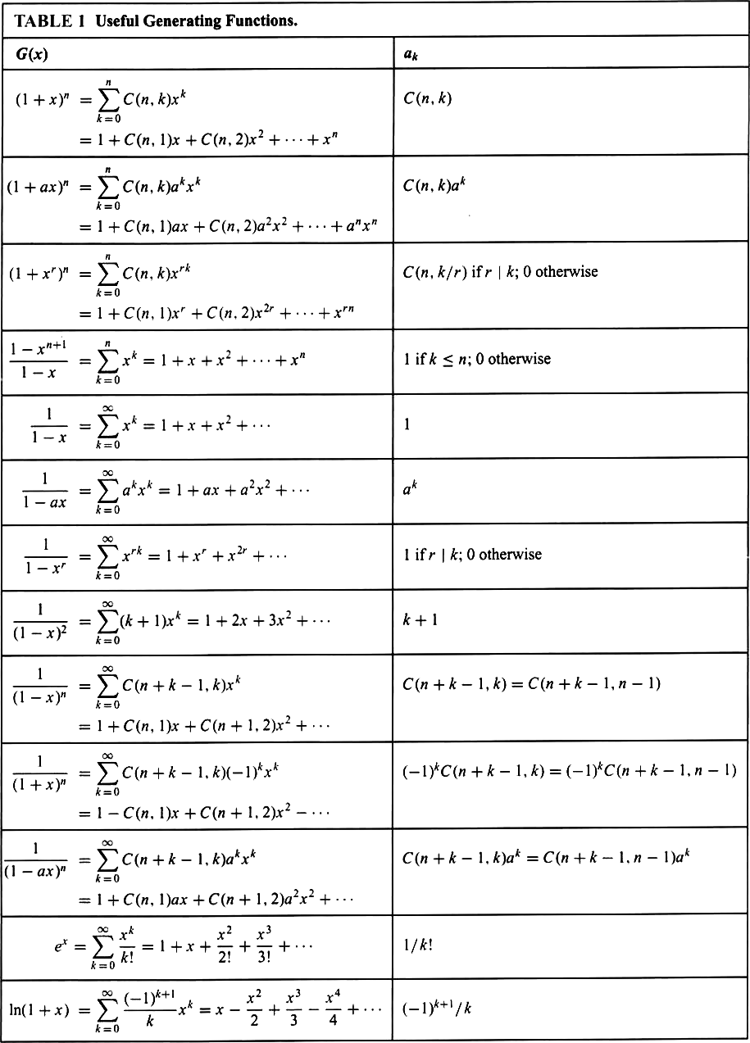

**Solving Recurrence Relation Using Generating function:**

Generating function can be used to solve recurrence relation

Procedure :

Translate a recurrence relation for the terms of a sequence into an equation involving generating function

This equation can be solved to find a closed form of the generating function

From this closed form, the coefficients of the power series for the generating function can be found solving the original recurrence relation

Solve the recurrence relation $a_{k}=3a_{k-1}$ for k=1,2,3.. and given $a_{0}$ =2

Solution:

Let G(x) be the generating function for the sequence {$a_{k}$}

i.e. G(x)= $\sum_{k=0}^{\text{∞}}{a_{k}}$ $x^{k}$

xG(x)= $\sum_{k=0}^{\text{∞}}{a_{k}}$ $x^{k+1}$ = $\sum_{k=1}^{\text{∞}}{a_{k-1}}$ $x^{k}$

Using the recurrence relation, we get

G(x) – 3xG(x) = $\sum_{k=0}^{\text{∞}}{a_{k}}$ $x^{k}$ $- 3\sum_{k=1}^{\text{∞}}{a_{k-1}}$ $x^{k}$

G(x) – 3xG(x) = $a_{0}+$ $\sum_{k=0}^{\text{∞}}{(a_{k}-3}a_{k-1}$) $x^{k}$

(1 – 3x)G(x) = 2

G(x)= $\frac{2}{1-3x}$

G(x)=2 $\sum_{k=0}^{\text{∞}}{3^{k}}x^{k}$

Hence $a_{k}$ = $2⋅3^{k}$

**Applications of Generating function**

* Generating functions are used in a wide area from statistics to mechanics, from combinations to cryptology, especially in topics involving sequences.

They help us

* to find the explicit formula for the general term of a sequence
* to find recurrence relations
* to compute averages and some other statistical properties
* to prove some mathematical identities